summary of Phase 1 close-out interviews
JLA conducted interviews with 23 of the 26 members of the Investment Strategy committee between April 20 and May 6 to close out the phase 1 process and inform the next steps for phase 2 work.
This summary describes the key themes heard from Investment Strategy committee members with regard to their perspectives on the overall process, the three proposed investment strategy approaches and next steps.
A more complete summary will be developed in the coming weeks.

Overall Process
Members felt the process overall was productive, including:
- Information sharing was positive and better relationships were formed through the dialogue that occurred. WSDOT/RTPOs/MPOs were able to hear and consider different perspectives and processes.
- There was a perceived lack of trust amongst those participating; however this process was seen as a first step in helping to build trust.
- Establishing subcommittees was useful to bring more focus to the process and earn trust.
- A greater understanding was gained with regard to the equity gap between rural and urban areas.
- A greater understanding of the different dynamics of each region/MPO/RTPO became clear, including their character, capacity and available resources.
- There was acknowledgement of the need for preservation and maintenance of the state system.
- It was beneficial to have time with the Secretary and hear that regional planning has value.
- Generally, the three proposed strategies are headed in the right direction.
Opportunities for improvement moving forward:
- Be clear about the desired outcomes, goals, timeline and level of commitment.
- Provide clear understanding of roles and responsibilities of WSDOT, RTPOs and MPOs up front.
- Provide project status context between/at every meeting to keep things on track. Recap videos were useful way of doing this.
- Keep the Investment Strategy committee informed of pilot progress moving forward.
- Consider in-person meetings at key decision points.
- Consider how to involve board members/electeds/legislature in future discussions.

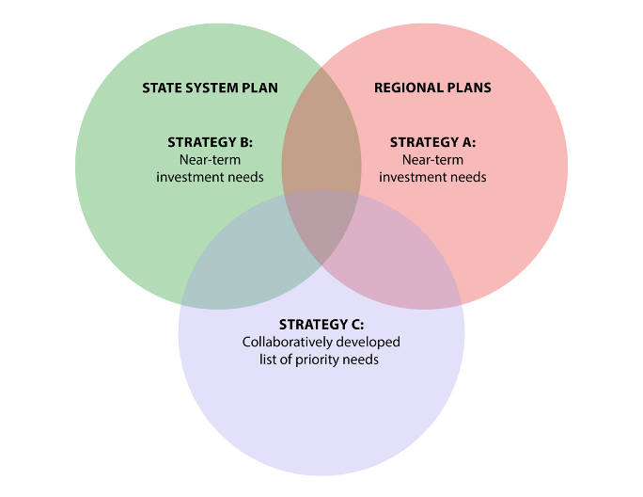
Strategy A: RTPOs/MPOs will identify near-term regional legislative priorities for state project and programmatic funding; and may build on existing regional models to do so.
Feedback received/desired outcomes:
- Great opportunity to establish some norms across the state by evaluating what each region is doing and improve upon the process as needed.
- Looking at how others identify priorities will reinforce how some processes can be done better or differently in each region.
- Provides an opportunity to support collaborative decision-making at the regional level and acknowledge regional priorities by the state.
- Some RTPOs/MPOs will be working on Strategy A regardless; that will put them in a better position (and be better informed) to participate in strategy C.
- WSDOT (Regional Administrators and headquarters) needs to participate in the process and acknowledge the priorities of the RTPO/MPOs.
- Strategy A is good because it builds on existing processes – it’s not a big ask. It’s a win-win, especially if it’s a shorter list borne off the RTP.
- Find examples of existing processes that work well in the state and identify components that could be replicated elsewhere so other regions could take that on.
- Councils/Boards will need to be involved to get agreement on prioritizing in a more standardized way.
- Concern about implementation for lightly resourced RTPOs, or RTPOs who don’t currently have a process for prioritization.
Strategy B: In order to explore how to collaborate in the future, WSDOT will outline the recent policy tradeoff decisions made to determine the FY 21-23 budget provided to the Governor and identify the regional benefits, as well as where there can be opportunities for input by the RTPOs/MPOs in the future.
Feedback received/desired outcomes:
- Improve trust, transparency and relationship building by creating a better understanding of the legislative process, the state budget process and the regional process.
- Provides a great opportunity for WSDOT to share with the RTPOs/MPOs how they prioritize projects to better understand the constraints and issues.
- Strategy B could be used as an opportunity to engage and inform the RTPO/MPO Boards.
- Strategy B is a must in order to understand what the state does and why it does it and what priorities the state is promoting.
- Opportunity to share information on how some projects are more important than others with regards to preservation, maintenance and safety. Provide an understanding of the methodology/formulas, especially if they impact the RTPO/MPOs.

Strategy C: A group of at least two interested RTPOs/MPOs and WSDOT will pilot a process which collaboratively identifies transportation investments supported by all participating agencies.
Feedback received/desired outcomes:
- This will be the most challenging to implement going forward.
- Strategy A and B will inform Strategy C.
- Has the opportuity to create balance between urban and rural regions by providing a voice at the table and creating a level playing field.
- Provides an opportunity to connect the RTPs on a statewide level to create regional and state alignment. It’s a way to roll up the regional plans into state priorities.
- Consider models across the nation like Utah or Minnesota DOT that could work and try them out. Consider more than one model to see what works best.
- Consider developing a training on the role of RTPOs for local agencies to promote the prioritization process and highlight the needs.
- WSDOT headquarters will need to be involved, not just the regions.
- Needs to be applicable to other agencies. Can’t be a cookie cutter approach.
- Provides an opportunity to shape how investments are made in the state and demonstrate how collaboration can inform decision-makers, not take decisions away from them.
- The important part of this effort is idenitfying if we can we message together.
- Only way to have value in the pilot is to have more than one RTPO/MPO participate to demonstrate value in prioritization.
- Concern that this process won’t be supported by the legislature.
- Concern about garnering board’s support and agreeing not to pursue other local projects/priorities.
- Concern about the political process – moving it out from the legislature to the regions.

Next Steps
The second phase of this work will be guided by volunteer subsets of the Investment Strategy Committee interested in piloting these approaches to identify transportation investment priorities. The full Investment Strategy committee will likely meet quarterly to be briefed on progress and provide feedback to the teams working on pilot testing.
- Strategy A is already occurring to some extent with some of the RTPOs/MPOs. A volunteer group of RTPOs, MPOs and WSDOT could be established to identify best practices to be shared with the larger Investment Strategy committee over the next biennium.
- Strategy B is anticipated to take place this summer as a workdshop led by WSDOT with input from RTPO/MPO members on content and format. This effort has the potential to continue at least annually moving forward as an ongoing training opportunity.
- Strategy C is a long-term, north star goal and will take time to evolve and implement through pilot testing. Strategy C will likely be informed through the A and B pilots, however early coordination of a volunteer group of RTPO, MPO and WSDOT members, can provide context for how this collaborative process could evolve.

